**DATA MINING on HOME FORESTATION**

**BY**

**TANVEER HOQUE**

**ID: 153-15-6334**

This Report Presented in Partial Fulfillment of the Requirements for the Degree of Bachelor of Science in Computer Science and Engineering

Supervised By

**Ms. ZERIN NASRIN TUMPA**

Lecturer

Department of CSE

Daffodil International University



**DAFFODIL INTERNATIONAL UNIVERSITY**

**DHAKA, BANGLADESH**

**OCTOBER 2018**

**APPROVAL**

This Project titled **“DATA MINING ON HOME FORESTATION**”, submitted by Tanveer Hoqueto the Department of Computer Science and Engineering, Daffodil International University, has been accepted as satisfactory for the partial fulfillment of the requirements for the degree of B.Sc. in Computer Science and Engineering (BSc) and approved as to its style and contents.

# BOARD OF EXAMINERS

|  |  |
| --- | --- |
| **Dr. Sayed Akhter Hossain**  **Professor and Head Chairman**  Department of CSE  Faculty of Science & Information Technology  Daffodil International University | **Chairman** |
| **Dr. Sheak Rashed Haider Noori Internal Examiner**  **Associate Professor and Associate Head**  Department of CSE  Faculty of Science & Information Technology  Daffodil International University | **Internal Examiner** |
| **Ms. Zerin Nasrin Tumpa**  **Lecturer**  Department of CSE  Faculty of Science & Information Technology  Daffodil International University | **External Examiner** |

# DECLARATION

We hereby declare that this project has been done by us under the supervision of **Ms. ZERIN NASRIN TUMPA,** Senior Lecturer**, Department of CSE** Daffodil International University. We also declare that neither this project nor any part of this project has been submitted elsewhere for award of any degree or diploma.

|  |  |
| --- | --- |
| **Supervised by:** | **Submitted by:** |
| **Ms. ZERIN NASRIN TUMPA**  Lecturer  Department of CSE  Daffodil International University | **TANVEER HOQUE**  ID: 153-15-6415  Department of CSE  Daffodil International University |

# ACKNOWLEDGEMENT

I want to express my solid gratitude to the almighty Allah for his divine blessings that makes me possible to complete the thesis successfully.

I would like to thank my thesis advisor Ms. Zerin Nasrin Tumpa, Lecturer, Department of CSE Daffodil International University, Dhaka. The door was always open for me to reach her with all the problems I faced. Struggling through her hardest times of life, she had always been with me and supported me more like my elder sister. I lost my directions so many times during my research, so was she for the loss of her brother. But she remained strong to instruct me through the very best direction to the end.

I would also like to convey my gratitude to Syed Akter Hossain, Head, Department of CSE, for his involvement in the validation survey for this research project. Without passionate participation and input, the validation survey could not have been successfully completed.

Finally, I must express my very profound gratitude to my parents. They provided me with unfailing support and continuous encouragement throughout these years of study and through the process of my research and writing this thesis. Without their support, I could not have fulfilled my dreams. All the hardships and sacrifices they made; I can’t ever repay. I want to end my acknowledgment with a famous quote of *Robert Herjavee*

"*I had to be successful to justify my parents’ sacrifice for me*"

.

# ABSTRACT

This paper automates plant monitoring, data collection and smart gardening using IoT in the Arduino Platform. Home forestation such as gardening in rooftop, balcony, living room has now a days become common in urban areas, because there are less land resources to plant trees. Also, it increases interior beauty of a house. In urban areas trees are decreasing day by day at an alarming rate. At the same time, the population is increased proportional to the decrease of trees. As a result, the air is polluted at a massive rate in urban areas. Home forestation or gardening is a smart solution to this life-threatening problem. But in urban areas, people lead busy life. They have less time to do gardening with proper knowledge. A plant needs 4 basic elements to grow such as: Light, Humidity, Temperature, Soil moisture. Every plant requires different environment variables. The motive of this research is to conduct data mining on these four elements in home environment to analyze the environment requirements for survival of each plants based on Plant taxonomy. In future, it will help me to make a smart platform “Eco Friend” which will suggest users the plants that are best for his home environment. The data will be collected using IoT including the device Arduino Uno, Nodemcu, Sensors and later analyzed with Data mining tools.

# List of Figures

**TABLE OF CONTENTS**

|  |  |
| --- | --- |
| **CONTENTS** | **PAGE** |

BOARD OF EXAMINERS ii

DECLARATION iii

ACKNOWLEDGEMENT iv

ABSTRACT v

List of Tables vi

List of Figures vi

Chapter 1: Introduction 1

1.1 Introduction 1

1.2 Motivation 2

1.3 Rationale of the Study 2

1.4 Research Questions 2

1.5 Expected Output 2

1.6 Report Layout 3

Chapter 2: Background 4

2.1 Introduction 4

2.2 Related Works 4

2.3 Research Summary 4

2.4 Scope of the Problem 4

2.5 Challenges 4

2.5 Hardware Requirements 5

Chapter 3: Research Methodology 13

3.1 Introduction 13

3.2 Research Subject and Instrumentation 13

3.3 Data Collection Procedure 13

3.4 Statistical Analysis 13

3.5 Implementation Requirements 13

Chapter 4: Experimental Results and Discussion 14

4.1 Introduction 14

4.2 Experimental Results 14

4.3 Descriptive Analysis 14

4.4 Summary 14

Chapter 5: Summary, Conclusion, Recommendation and Implication for Future Research 15

5.1 Summary of the Study 15

5.2 Conclusions 15

5.3 Recommendations 15

5.4 Implication for Further Study 15

References 17

Appendices 18

Appendix A: Research Reflection 18

Appendix B: Related Issues 18

# Chapter 1: Introduction

## Introduction

An indoor garden is often either sophisticated or straightforward as somebody wants. One can pay thousands of moneys to create a garden, or even pay a bit. horticulture could be a fun and relaxing way to get connected with nature. gardening is an activity that’s smart for both the mind and body at a similar time. It may be enjoyed and practiced by individuals of any ages. It’s easy, grab your tools and get in the dirt! Is it really that much easy?

IoT (Internet of Things) is usually stated as internet of Objects, since IoT can rework anything-including ourselves. This bold statement is given by considering the impact of web on education, business, communication, science and humanity, etc. Kelvin Ahston used the term IoT first in 1998, that currently has additional and additional developed. all told of human history the foremost powerful and vital creation is that the net. The integrated a part of future web is IoT. within the field of business, human process, info and communication, the things are expected to become active participants by using IoT. they have to be enabled so as to be able to move with the surroundings themselves by reworking and exchanging the data and knowledge detected regarding the environment. It reacts mechanically to the real-world events and is influenced by the processes that make services and trigger actions with or while not human intervention.

The planned system is intended and enforced employing a low-priced Mastercard sized Nodemcu, that is controlled through internet under the windows environment. The smart device collects home environment and sends the info to server. It logs the info and stores them as data. Later they're classified using data processing tools. the complete platform is developed to gather the desired information of a future device. The device can observe home environment, collect and analyze information, send this to server, the server can respond according the matched criteria of the surroundings and return relative tree recommendations. This plant watching system will offer water and light consistent with necessity.

All garden parameters like humidity, temperature, soil moisture, light intensity is tracked by the system and this data is uploaded in the cloud.

Eco Friend (the device itself) incessantly monitors the conditions of the garden and collects each amendment of information that need immediate actions for the garden and advise the user.

## Motivation

Plants are essential for life in earth. None of our basic functions from breathing to eating to drinking would be possible without plants. Plants not only act as food sources but also release oxygen and help maintain the water table. The simple fact of the matter is that without plants we cannot survive.

In today’s busy world, we always have little time to know every detailed information. But lack of information could spoil a perfectly planned decision. My roommate has 3 plants. 2 of them are already dead and another is about to die. Why that might have happened? Because he went to a local nursery plant shop, there he found three trees that had cool color flowers, leaves were beautiful. He asked himself how much would they suite the beauty of his balcony, and he found out they would quite an impression. They really were beautiful at first. He used to care for them, nurture them, water them. But after some time, he got himself busy with daily life. About a matter of time, these plants faced their destiny, and gets rotten. What if he knew, which plants was best for his environment? Which plants needed less nurture and attention. Maybe that could save his money and time. So, this device helps to learn more about the environment that a tree can survive, and then generate a database. Using the database, a user can learn which plants suits the criteria of his home environment and necessity (based on purpose, e.g. vegetable plants, flower plants, medicinal herbs, leaflet plants.

## 1.3 Rationale of the Study

There are so many projects on IoT is undergoing right now to make smart garden, which involves in smart watering and lighting systems. They use advanced technique and method using IoT devices and android platform to make user friendly gardening.  
This research the gardening is taken to a whole new level by implying data mining techniques on home environment.

## Research Questions

These are few research questions regarding my research topic

* Does gardening needs to computer supervision rather than basic gardening knowledge?
* Can smart gardening reduce tree death rate?
* Accuracy of the data collected is up to the standard?
* How much adaption is possible in the variation of plants?

## 1.5 Expected Output

1. Analyze experimental environment
   1. The device will gather the information based on room environment
      1. Light intensity
      2. Temperature
      3. Humidity
   2. I will also get the information based on plants
      1. Soil moisture
   3. Collect and format data
   4. Send data to the server
   5. The server will do the following
      1. Save the requested data
      2. Notice any unnecessary
   6. Scrapping the database
      1. Get plants upper and lower threshold limit of environment variables
2. Analyze user environment
   1. We will get the information based on room environment
      1. Light intensity
      2. Temperature
      3. Humidity
   2. Provide water to plants when necessary based on soil moisture
3. Interact with user
   1. Maintain
      1. Automatic water system
      2. Automatic lighting system
      3. Notify user about the tree

## 1.6 Report Layout

**Chapter 1: Introduction**

In this chapter, we have discussed the motivation, objectives and the expected outcome of the project.

**Chapter 2: Background**

We discuss the background circumstances and hardware details of our project. We also talk about the related work, comparative studies, scope of the problem and challenges of the project.

**Chapter 3: Research method**

In this chapter, we discussed the requirements like the use case model of the project and their descriptions, the logical data model and the design requirements.

**Chapter 4: Experimental results and discussion** in this chapter, we discussed all the designs of the research with proper descriptions. We also discussed about individual result descriptions.

**Chapter 6: Conclusion and Future Scope** We discussed the conclusion and the scope for further developments which can make a vast sector for this system.

# Chapter 2: Background

## 2.1 Introduction

As per the growing rate of population with spontaneous consumption of resources, creates in the need for the managing the available resources at its best. So, a need was felt to manage the outflow of the two major resources i.e. water and electricity and to formulate out, that’s how it can be protected from getting wasted and could be utilized at its best.

As during the survey study, it was found that (Dhaka, in Bangladesh) the practices were manual and a major portion of resources was wasted due to slothful and unconcerned behavior leading to the death of trees and unwanted operation of the lights.

So, using modern technology, and statistical, survey-based study it was found that that major portion of the resources (water and Electricity) could be managed out and preserved by managing their controlled flow in an allocated area.

## 2.2 Related Works

There are lots of works on IoT devices regarding smart plant monitoring system. There are logs to classify the environment required to plant

## 2.3 Research Summary

## 2.4 Scope of the Problem

## 2.5 Challenges

The proposed device should have the following challenges to overcome

* To operate in friendly environment
* To work with cheap device that is prone to error
* Irrelevant data
* Working with massive datasets and options

## 2.6 Hardware Requirements

There were lots of parts and devices used to complete the device. Some of them finally came out with limitations. These were replaced or removed later. The final parts that makes the final device is as follows:

* + 1. **Nodemcu**

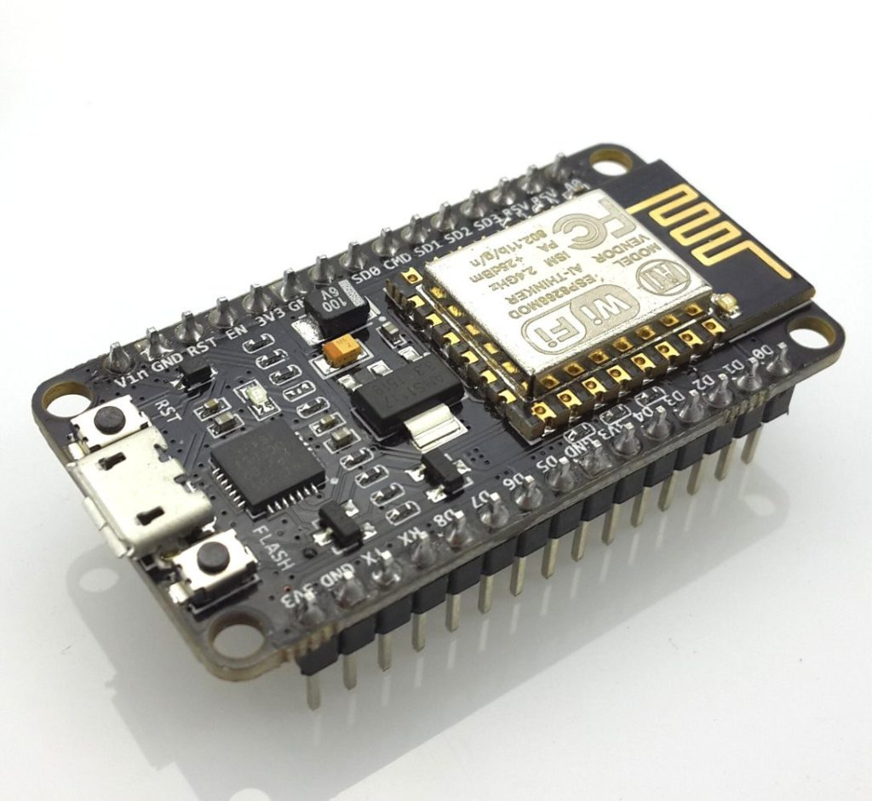

The NodeMCU is a development board that includes the favored ESP8266 Wi-Fi chip. as it seems, you'll be able to program the ESP8266 a bit like the other microcontroller. Its obvious advantage over the Arduino or PIC is that it will promptly connect with the web via Wi-Fi. However, the ESP8266 prison-breaking board has restricted pins though the chip itself contains a heap of output ports. The NodeMCU solves this drawback by that includes ten GPIO pins each capable of using PWM, I2C and 1-wire interface.**[1]**

* + 1. **DHT11**

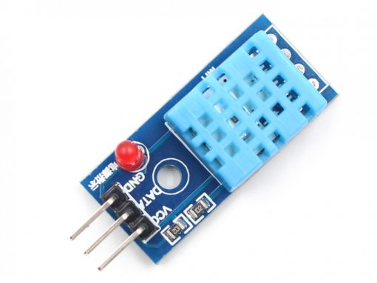**[2]**

DHT11 is a humidity and Temperature detecting sensor, that generates calibrated digital output. DHT11 are often interface with any microcontroller like Arduino, Raspberry Pi, etc. and find fast results. DHT11 may be a affordable humidity and temperature detector that provides high reliability and long stability.

It uses a capacitive humidity detector and a semiconductor to measure the encircling air, and outputs a digital signal on the data pin (no analog input pins needed). It’s terribly straightforward to use, and libraries and sample codes are accessible for Arduino and Raspberry Pi.

This module makes is simple to attach the DHT11 detector to an Arduino or microcontroller as includes the pull up resistance required to use the detector. solely 3 connections are needed to be created to use the detector – Vcc, Gnd and Output.

It has high reliability and glorious long stability, because of the exclusive digital signal acquisition technique and temperature sensing technology.

Specifications: -

Power Supply： 3.3~5.5V DC

Output： 4 pin single row

Measurement Range： Humidity 20-90%RH， Temperature 0~50℃

Accuracy： Humidity +-5%RH， Temperature +-2℃

Resolution： Humidity 1%RH， Temperature 1℃

Interchangeability： Fully Interchangeable

Long-Term Stability： <±1%RH/year

Pin Description: -

Pin 1: Power +ve (3.3VDC to 5.5VDC Max wrt. GND)

Pin 2: Serial Data Output

Pin 3: Power Ground or Power –ve

* + 1. **Capacitive Soil Moisture Sensor v1.2**

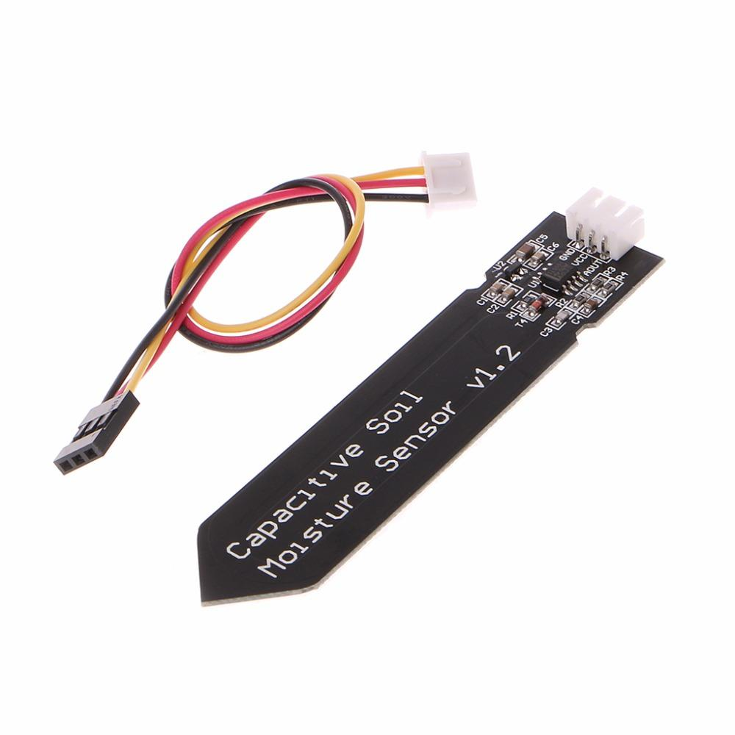**[3]**

soil moisture device measures soil moisture levels by electrical phenomenon sensing instead of resistive sensing like alternative sensors on the market. it's made from corrosion resistant material which provides it a wonderful service life. Insert it in to the soil around your plants and impress your friends with real-time soil moisture data! This module includes an on-board transformer which provides it an operative voltage vary of 3.3 ~ 5.5V. it's excellent for low-voltage MCUs, both 3.3V and 5V. For compatibility with a Raspberry Pi it'll need an ADC convertor. This soil moisture device is compatible with our 3-pin "Gravity" interface, which might be directly connected to the Gravity I/O enlargement shield.

* + 1. **Digital Light intensity sensor module**

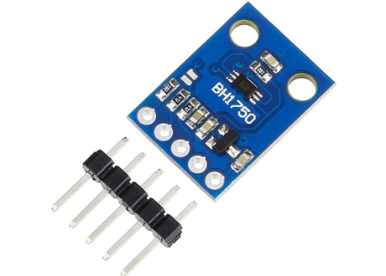**[4]**

BH1750FVI is a digital ambient light sensing element IC for I2 C bus interface. This IC is the best suited to get the ambient light information for adjusting liquid crystal display and keyboard backlight power of Mobile Phones. it's attainable to find wide selection at High resolution. It’s Spectral responsibility is roughly human eye response. This has terribly low source of illumination dependency like electric lamp, lamp, halogen Lamp, White LED. there's No need of any external elements and comes with 50Hz or 60Hz light noise reject function. it's attainable to pick two kind of I2C slave-address.

Adjustable measuring result for influence of optical window. The influence of infrared is extremely little. it's application in mobile, LCD TV, NOTE PC, transportable game machine, photographic camera, Digital video camera, PDA, liquid crystal display, DIY projects, robotics projects, Arduino projects, Raspberry-Pi projects, Electrical or Electronic projects.

* + 1. **Nokia 5110 LCD Display**

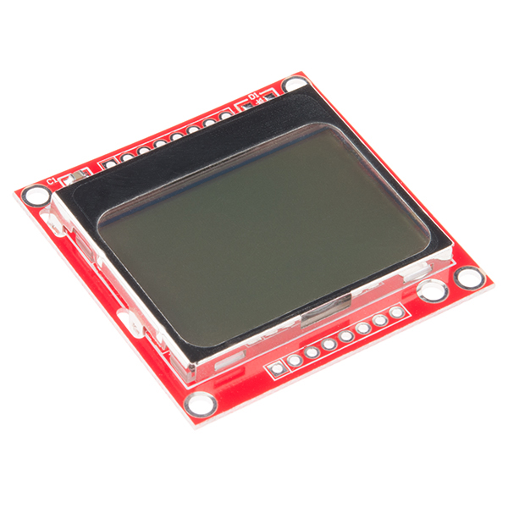[5]

The Nokia 5110 is a basic graphic LCD screen for ample applications.

It was originally supposed to be used as a cellular phone screen.

This one is mounted on a straightforward to solder PCB.

It uses the PCD8544 controller, that is the same utilized in the Nokia 3310 liquid crystal display.

The PCD8544 could be a low power CMOS LCD controller/driver, designed to drive a graphic display of forty-eight rows and eighty-four columns.

All necessary functions for the display are provided in an exceedingly} very single chip, in conjunction with on-chip generation of liquid crystal display offer and bias voltages, resulting in a minimum of external elements and low power consumption.

* + 1. **Jumper wires**

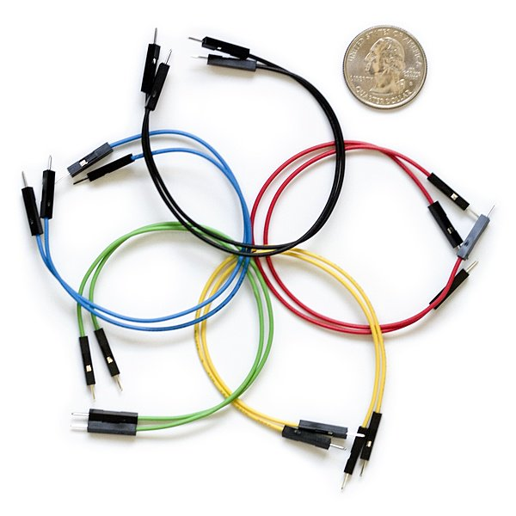[6] Jumper wires are merely wires that have connection pins at every end, permitting them to be used to connect 2 points to every other without soldering. Jumper wires are usually used with breadboards and alternative prototyping tools so as to create it simple to change a circuit as required. Fairly easy. In fact, it doesn’t get way more basic than jumper wires.

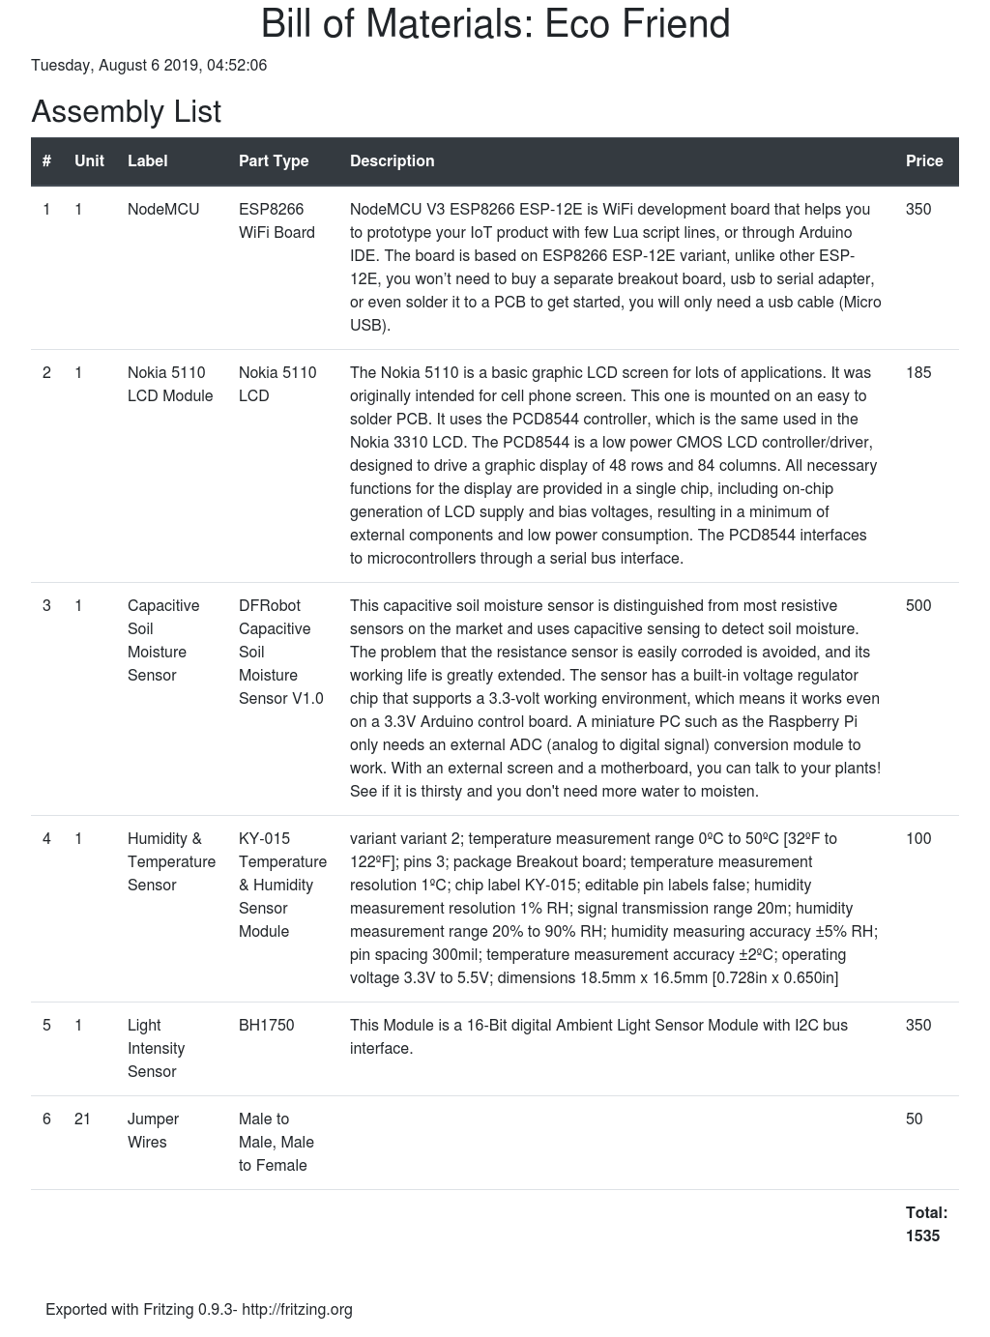**Parts Bill**

## Software Requirements

The below softwares were used to complete the project:

* + 1. Arduino IDE
    2. Draw.io
    3. Fritzing
    4. PyCharm Professional

# Chapter 3: Research Methodology

## 3.1 Introduction

The automatic plant monitoring system has recently attracted tremendous interest due to the potential application in emerging technology. More importantly, this technique is used to enhance the performance of existing techniques or to develop and design new techniques for the growth of plants. The plant monitoring system is helpful for watering the plants and to monitor few parameters for growth of plants. This system is very used in few areas like nursery farms and in agriculture. In this system a mechanism is established to find the moisture content in the soil with the help of soil moisture sensor and depending upon the condition of the sensor the water is controlled. Another important parameter is by capturing the light, temperature and humidity of the environment by using NodeMCU, and processing the data by using data mining technique to analyze and determine the environment. This helps in providing the appropriate amount of water for plants so reduces some situations like mud cracks, water logging. This helps in irrigating the field even during night time, so does not require the user to switch ON the motor manually.

## 3.2 Research Subject and Instrumentation

## Data Collection Procedure

### Flowchart

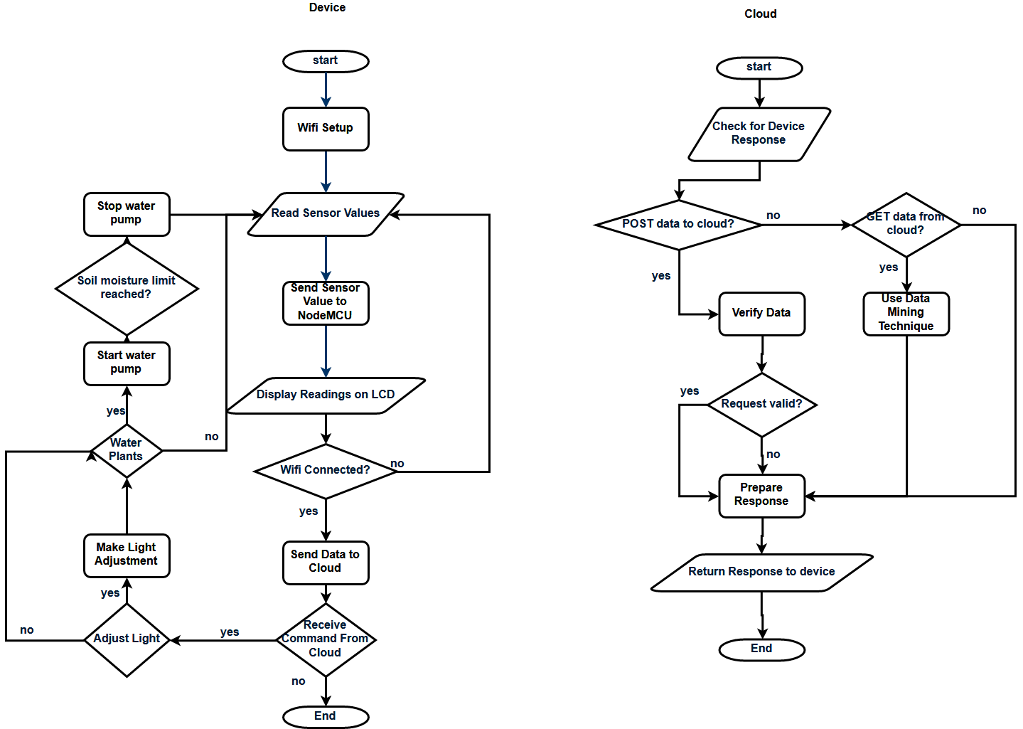

### Diagram

### Circuit Diagram

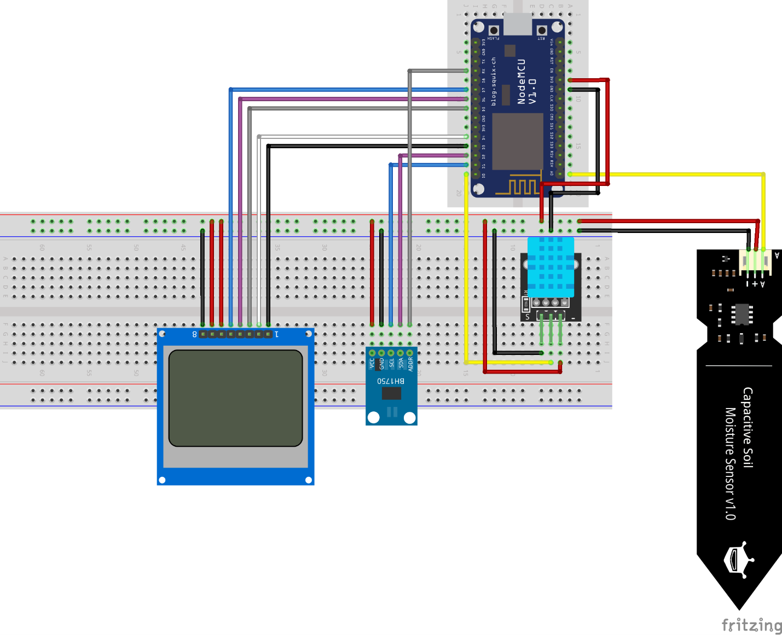

## 3.4 Statistical Analysis

## 3.5 Implementation Requirements

# Chapter 4: Experimental Results and Discussion

## 4.1 Introduction

## 4.2 Experimental Results

## 4.3 Descriptive Analysis

## 4.4 Summary

# Chapter 5: Summary, Conclusion, Recommendation and Implication for Future Research

## 5.1 Summary of the Study

The goal of our research is to build an advanced gardening support system called the Eco Friend. Eco Friend supports gardeners in making planting decisions. With increasing numbers of people in Bangladesh and increasing interest in healthy eating, home gardening is becoming more and more popular. How-ever, it is difficult for beginners to plan gardens because of the wide range of factors to consider, such as soil, weather, climate. Eco Friend supports decisions about what to plant where with data collected by sensors and organized in a database. The concept of Eco Friend is based on precision agriculture, which uses information technology to bring together data from multiple sources to support decisions associated with crop production. Eco Friend uses sensors to collect data in the real world that it then plots in a cloud database. Various models then forecast possible fertilizer needs, pest control needs, and yields. Growers carry out actions based on the forecasts and evaluate the results.SG allows growers to set their own goals. Growers might pursue yield, or particular vegetables, or a mix of flowers, herbs, and vegetables, or a balance of fragrant and beautiful plants. SG uses computer models to forecast the outcomes of management decisions, and the technology of Data Mining (AR) to show the grower the predicted results.

## 5.2 Conclusions

Analyzing and Datamining using IoT with the assistance of a NodeMCU controller helps to ease the foremost tedious job of farming for plant lovers who are in a very time of rush. this method monitors numerous garden parameters and store the data in details of garden through the device. It conjointly helps to unravel several problems occurring within the existing plant watering and farming system. It helps to avoid wasting water and utility bills. Plant observance and good farming mistreatment IoT with the assistance of the NodeMCU controller can bring a lot of convenience and luxury to individuals ‘s lives for taking care of their garden. The user will management and monitor the setting of the garden mistreatment internet application. The controller during this system (Raspberry Pi) provides associate economic and economical platform to implement the plant observance and good farming system mistreatment IOT. the most advantage of the good farming system is that the user will monitor the garden mistreatment the net from so much distances throughout leisure or whenever necessary.

## 5.3 Recommendations

## 5.4 Implication for Further Study

Drawbacks

* pH sensor module high price (Approx 2k+)
* limited analog pin of NodeMCU
* Limited digital pin of NodeMCU
* Technical difficulties

# References

* Sabequn Nahar Mukti (2006), Study of Urban Forestry through Road Side Tree Plantation in Dhaka City (2006), BUET, Dhaka
* Fabrizio Balducci(2018), Machine Learning Applications on Agricultural Datasets for Smart Farm Enhancement, Università degli studi di Bari Aldo Moro, 70125 Bari, Italy <https://www.mdpi.com/2075-1702/6/3/38/htm>
* Baihaqi Siregar et al 2018, Soil Moisture Monitoring System using WirelessSensor Network, J. Phys.: Conf. Ser.1028 01205 <https://iopscience.iop.org/article/10.1088/1742-6596/1028/1/012058>
* Kretschmar M and Welsby S 2005 Capacitive and Inductive Displacement Sensors Newnes (Burlington) [Google Scholar](https://scholar.google.com/scholar?q=Kretschmar+M+and+Welsby+S+2005+Capacitive+and+Inductive+Displacement+Sensors+Newnes+%28Burlington%29)
* Chen W 2013 Design and Deployment of A Wireless Sensor Network For The Monitoring of Plants (Harbin Institute of Technology) Disertation For The Master’s Degree in Engineering [Google Scholar](https://scholar.google.com/scholar?q=Chen+W+2013+Design+and+Deployment+of+A+Wireless+Sensor+Network+For+The+Monitoring+of+Plants+%28Harbin+Institute+of+Technology%29+Disertation+For+The+Master%E2%80%99s+Degree+in+Engineering)
* Adams J A 1986 Dirt. College Station Texas (Texas) [Google Scholar](https://scholar.google.com/scholar?q=Adams+J+A+1986+Dirt.+College+Station+Texas+%28Texas%29)
* Foth H D 1990 Fundamental of Soil Science (Michigan: Arcata Graphics Company) [Google Scholar](https://scholar.google.com/scholar?q=Foth+H+D+1990+Fundamental+of+Soil+Science+%28Michigan%3A+Arcata+Graphics+Company%29)
* Susana R 2013 Perancangan dan Realisasi Sistem Monitoring Parameter Tanah Berbasis Jaringan Sensor Nirkabel Jurnal Informatika 1-11 [Google Scholar](https://scholar.google.com/scholar?q=Susana+R+2013+Perancangan+dan+Realisasi+Sistem+Monitoring+Parameter+Tanah+Berbasis+Jaringan+Sensor+Nirkabel+Jurnal+Informatika+1-11)
* Serrano J, Shahidian S and Marquez da Silva J 2014 Spatial and TemporalPatterns of Apparent Electrical Conductuvity : DUALEM vs. Veris Sensors for Monitoring Soil Properties MDPI International Journal 14 10024-10041 [Google Scholar](https://scholar.google.com/scholar?q=Serrano+J%2C+Shahidian+S+and+Marquez+da+Silva+J+2014+Spatial+and+TemporalPatterns+of+Apparent+Electrical+Conductuvity+%3A+DUALEM+vs.+Veris+Sensors+for+Monitoring+Soil+Properties+MDPI+International+Journal+14+10024-10041)
* Stevanus and Setiadikarunia D. 2013 Alat Pengukur Kelembaban Tanah Berbasi Mikrokontroler PIC 16F84. Indonesian Journal of Applied Physics 36-46 [Google Scholar](https://scholar.google.com/scholar?q=Stevanus+and+Setiadikarunia+D.+2013+Alat+Pengukur+Kelembaban+Tanah+Berbasi+Mikrokontroler+PIC+16F84.+Indonesian+Journal+of+Applied+Physics+36-46)
* Lee M H, Tsai D J and Lee C Y 2014 Applications of Soil Moisture Sensor with Elektrokinetic Ion Trap Mechanism. Hindawi Publishing Corporation TheScientific World Journal 14 1-8 [Google Scholar](https://scholar.google.com/scholar?q=Lee+M+H%2C+Tsai+D+J+and+Lee+C+Y+2014+Applications+of+Soil+Moisture+Sensor+with+Elektrokinetic+Ion+Trap+Mechanism.+Hindawi+Publishing+Corporation+TheScientific+World+Journal+14+1-8)

# Appendices

## Appendix A: Research Reflection

## Appendix B: Related Issues

1. https://www.teachmemicro.com/intro-nodemcu-arduino/
2. https://happyec.in/product/dht11-temprature-and-humidity-sensor-module/
3. https://wiki.dfrobot.com/Capacitive_Soil_Moisture_Sensor_SKU_SEN0193
4. https://robohaat.com/product/bh1750fvi-digital-light-intensity-sensor-module/
5. https://www.sparkfun.com/products/10168
6. http://blog.sparkfuneducation.com/what-is-jumper-wire